Need assistance ?

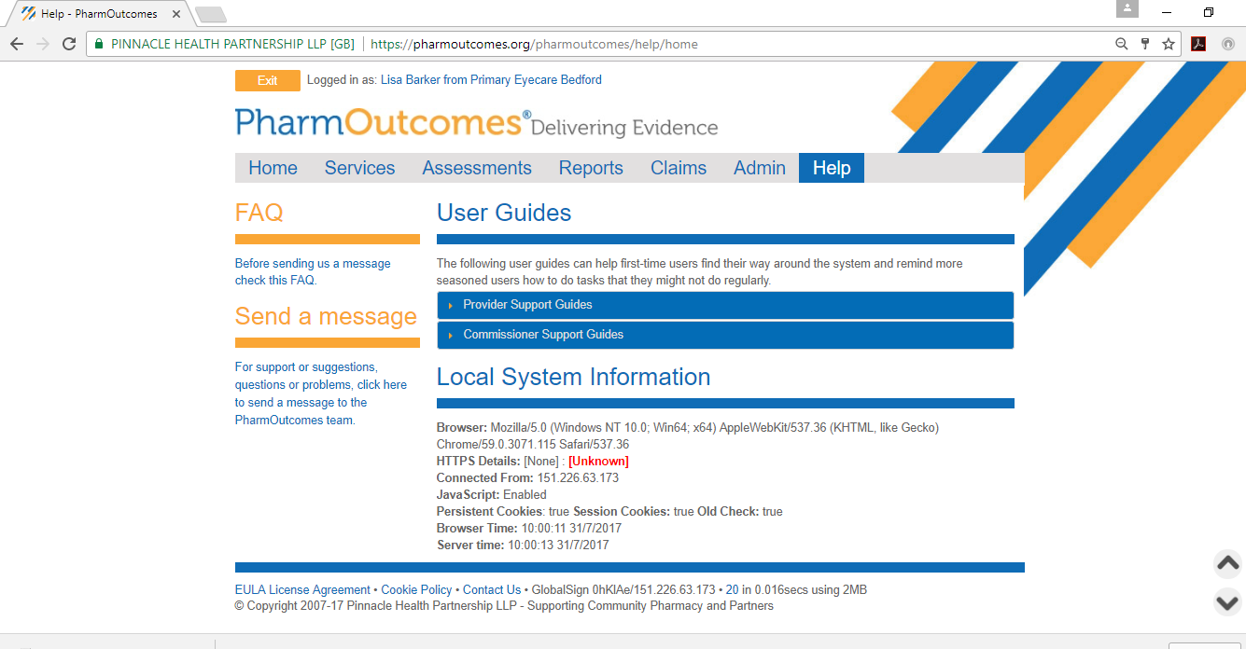
Select the help tab at the top of the page – click on send a message and fill in the relevant details.
